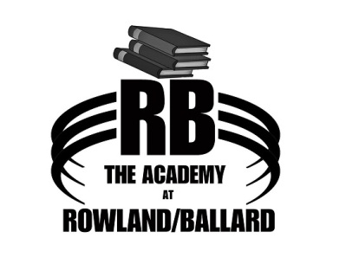

2017-2018 Academic Calendar
June: First Day of Summer Session June 5th
July: July 3rd & 4th Independence Day Holiday
August: August 25th Teacher Work Day
August 28th School Begins
September: September 7th Labor Day
October: No Holidays
November: November 22nd-24th Thanksgiving Holidays
December: December 18th-January 2nd Christmas Holidays
January: No Holidays
February: No Holidays
March: March 12th-16th Spring Break
March 30th Good Friday
April: No Holidays
May: May 28th Memorial Day
June: Last Day of School TBD ( May 31st, June 5th, or June 7th )

