Instruction for making a partial payment in the parent portal

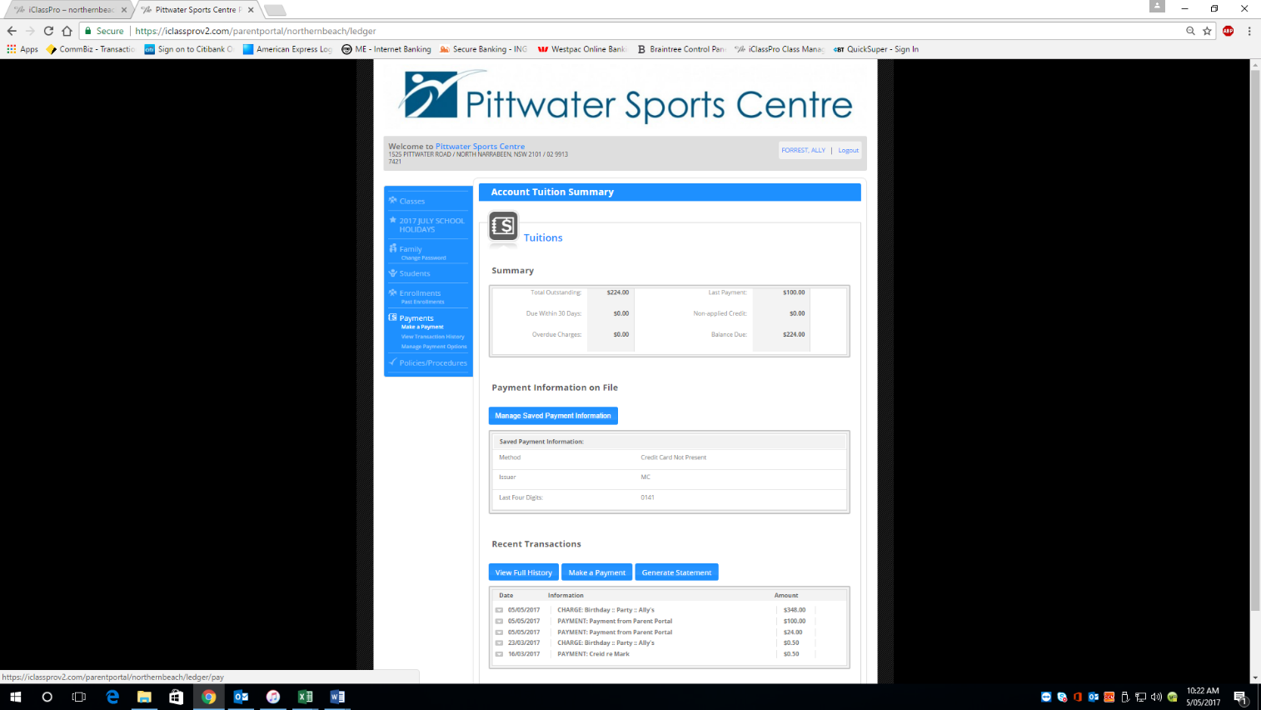
Open the portal and click make a payment

This screen will appear
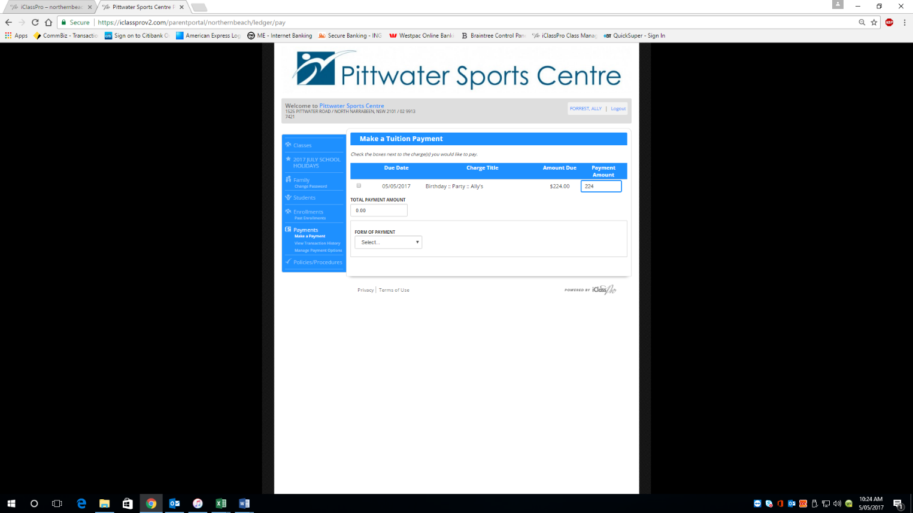

Clicking the box on the left then ONLY Use the TAB key to move forward
Click tab till Payment Amount is highlighted
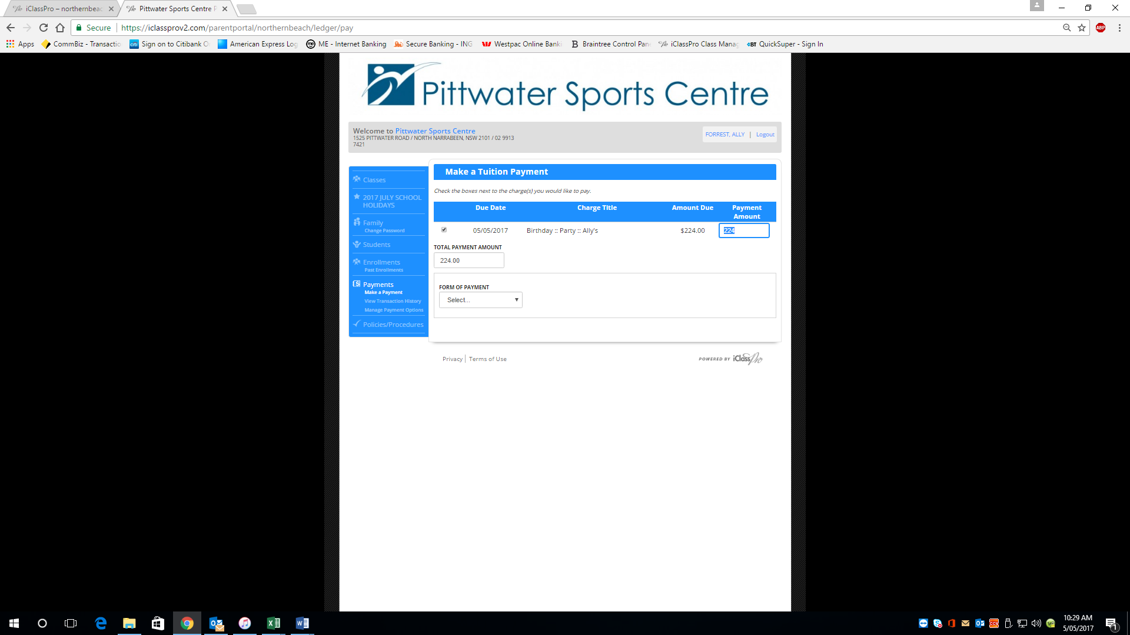

Type over the amount and then click tab
See Below
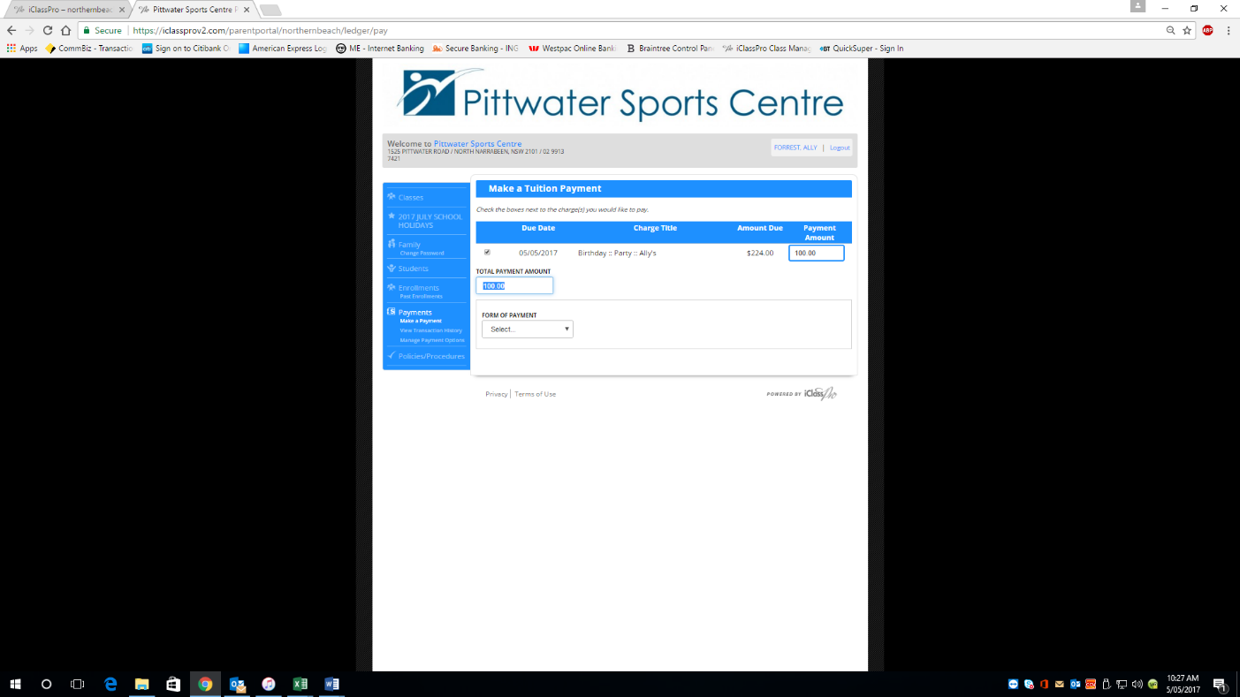
The Amount then will appear in the Total Payment Amount click tab again to go to form of Payment select the payment form and go to next pic

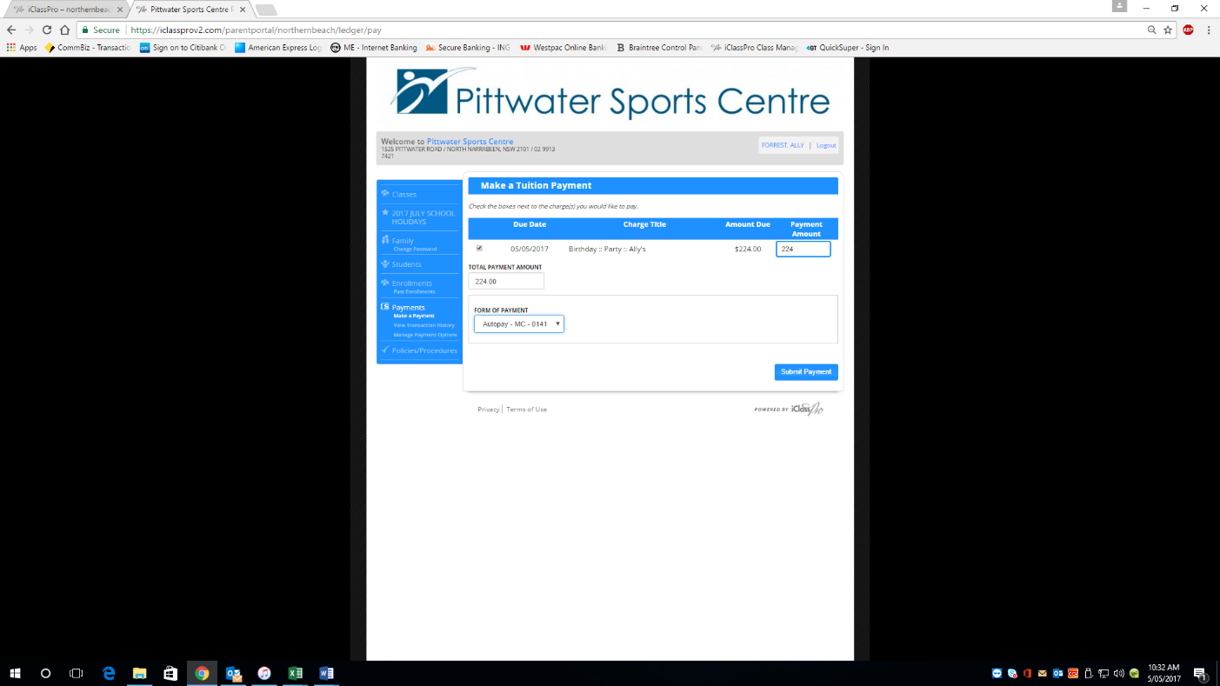
You will then see the Submit Payment click to submit

Payment made

